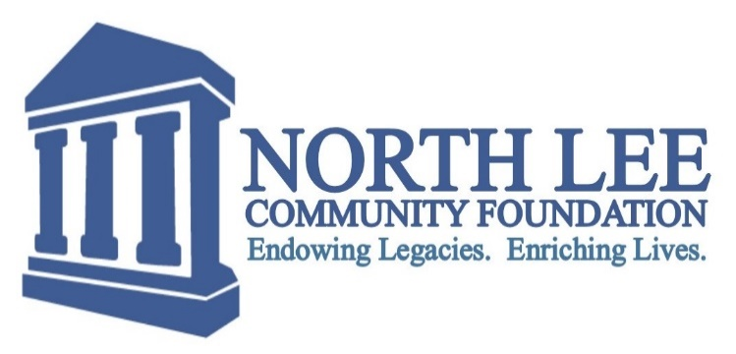
2022 North Lee Community Foundation Preview Grant Application

The North Lee Community Foundation makes grants to only North Lee County organizations. 501 (c) (3) organizations from Fort Madison, West Point, Houghton, St. Paul, Denmark or other North Lee County communities may apply. Grant application requests are considered in the fields of arts and culture, community betterment, education, religion, health, and human services. Grants are not awarded in the following areas: annual fund raising, organizational endowment funds, deficit financing, or for sectarian purposes.
Applying for a North Lee Community Foundation Grant
The 2022 North Lee Community Foundation Grant Application can only be submitted online. Once an applicant starts a 2022 North Lee Community Foundation Grant Application, they cannot save an application if it is not completed.
IRS Determination Letter
In the online application, please attach one copy of your organization’s up to date IRS Determination Letter establishing that the organization is a 501 (c) (3) organization of Lee County Iowa. If the organization receives a grant, the address listed on the IRS 501 (c) (3) Determination Letter will be used in the payment (please make sure the contact information of your organization's IRS 501 (c) (3) Determination Letter is up to date).
Deadline
All 2022 North Lee Community Foundation Grant Applications and accompanying materials are due on or before November 11, 2022. All 2022 North Lee Community Foundation Grant Recipients will initially be notified this November.

How to Apply for a Grant from The North Lee Community Foundation
- Prepare additional documents for upload within the 2022 North Lee Community Foundation Application
  - Current IRS Determination Letter (Required)
  - Total Project Budget (Optional)
  - Additional Information Attachment (explaining unusual or uncommon circumstances, optional)
  - Letters of Support (Optional 3 maximum, useful for newer projects and as evidence of collaborative activities)
- Go to www.northleecf.org (click the 2022 GRANT APPLICATION BUTTON)

Preview Questions
These questions are the exact questions on the 2022 North Lee Community Foundation Grant Application. THE FOLLOWING SHOULD ONLY BE USED AS A REFERENCE ONLY.

Section 1: Contact Information
- Date:
- Organization:
- Project Title:
- One Sentence General Description of Project:
- Amount Requested:
- Address:
- Is your organization a 501 (c) (3) nonprofit organization recognized by the IRS?
- Federal Tax ID#:
- IRS Determination Upload PDF (Required)
- Contact Person:
- Email:
- Phone #:
- Website:
- Project Start Date:
- Estimated Completion Date:
- Is this a new project for your organization?
- Is this a continuation/expansion/enhancement of a project?
- Categorize Project:
- Type of Project:

Section 2: Proposal Questions
1. What is the mission of your organization?
2. What is the purpose of this project?
3. What community need (s) does this project address?
4. How many people will be impacted by this project?
5. Does the project have a broad base of community support such as volunteer involvement, neighborhood participation, and collaboration with other organizations?
6. What outcomes/results will be achieved from this project?
7. Additional Information Attachment PDF (Optional)

Section 3: Budget and Authorization
1. Does the project have a sound financial plan?
2. What are some other funding sources of your organization's project?
3. After this project is completed, how will funding continue? If not funded, what is the effect?
4. If awarded a grant, how much of this grant will go to pay administrative salaries/wages? (Please include an amount or a percentage)

Please show a list of the expenses anticipated for the project. Attaching a budget is strongly recommended, but optional.
Material (s):
- Cost:

Total Cost:

Additional Budget Information (Optional)
Budget Attachment PDF (Optional):
Letters of Support PDF (Optional)

Authorization
I have read and understand the grant guidelines as part of this application. I also understand that when a grant check is cashed, my organization is obligated to use it for the purpose given in this application. The signature must be from the CEO, Executive Director or a Principal/Superintendent of your organization.

Application Questions or Help: Call Philip Ricketts, Grants Manager, at 319-670-0207 or email info@northleecf.org

